**Table of a Number**

Given a number n as input, we need to print its table.

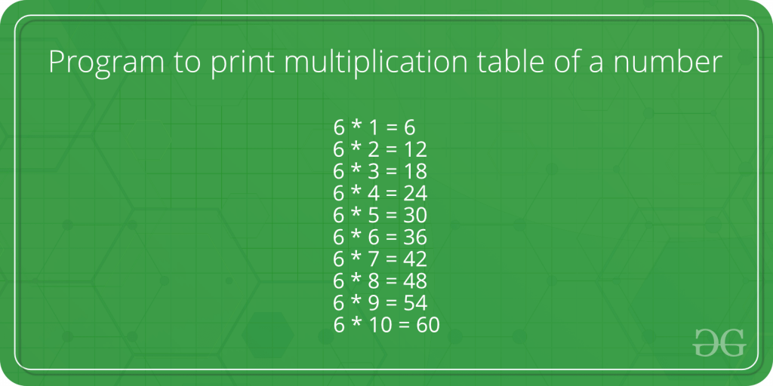

**Examples :** 

Input : 5

Output : 5 * 1 = 5

5 * 2 = 10

5 * 3 = 15

5 * 4 = 20

5 * 5 = 25

5 * 6 = 30

5 * 7 = 35

5 * 8 = 40

5 * 9 = 45

5 * 10 = 50

C++

#include<iostream>

using namespace std;

int main()

{

int n, m;

cin >> n >> m;

for(int i = 1; i <= m; i++)

{

cout << n*i << '\n';

}

return 0;

}

**INPUT :**

**5 2**

**OUTPUT :**

5

10